Employment Opportunities
Part Time & Casual Relief
Transportation Drivers
Recently Retired? Looking for Additional Income?
Have a desire to provide a service to your community?

Offers:
- 30 to 45 hours every two weeks with the possibility of additional hours depending on your availability.
- Saturday & Sunday Rotation once every 5 to 6 weeks

Qualifications/Requirements:
- Class G or Higher Ontario Drivers Licence
- A clean driving abstract covering a three-year period
- A desire to serve seniors, disabled & individuals with special needs in our community.
- The ability to lift/push 50+ lbs.
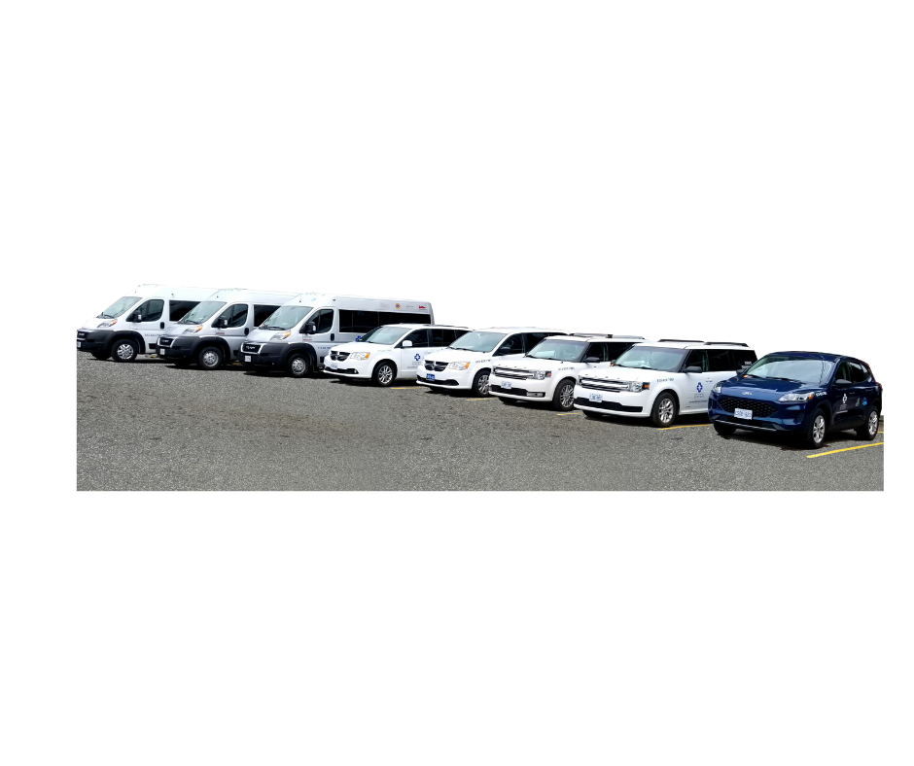
- $17.68 per hour

To be flexible and accommodating to a varying and sometimes unpredictable schedule including a predicted occasional weekend
A Transportation Service using agency vehicles designed to provide personal one to one assistance, door through door service for our community’s seniors, disabled and individuals with special needs.
Email Resume to: employmentopportunity@cssagency.ca

