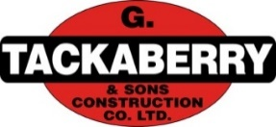

**Construction Labourers Needed**

Tackaberry Construction is a local, family run business, serving eastern Ontario since 1957. We offer competitive wages with group benefits. We are currently looking to hire Construction Labourers for jobs in various locations in Leeds and Grenville/Lanark area.

**Job Duties may consist of but are not limited to:**

* Hand shoveling and raking for rough grade
* Traffic control/flagging
* Road prep for paving crew
* Installing road signs and traffic barriers
* Other labour duties as required

**The successful candidate will be required to:**

* Work in all different types of weather conditions
* Stand for long periods of time
* Take direction from the job Foreman on site
* Have a Valid driver’s license with reliable transportation
* Communicate with others in a courteous and respectful manner

If you are a self-starter, interested in working in a fast-paced environment, please submit your resume with references to:

[careers@tackaberryconstruction.com](mailto:careers@tackaberryconstruction.com)

*G. Tackaberry & Sons is an equal opportunity employer. We wish to thank all who apply for this position, however, only those selected for an interview will be contacted.*